Simulating multicolour paintings on an upright easel with a robotic arm in a humanistic approach

Ray Prithviraj
School of Mechanical and Aerospace Engineering

Assoc Prof Anupam Chattopadhyay
School of Computer Science and Engineering

Abstract – The following research paper aims to analyse the methods which can be utilised to make a robotic arm perform multicolour paintings in a humanistic manner[1] and simulate the method that’s understood to be the most efficient.
Traditionally, the initial models designed to perform robotic paintings would involve a cartesian approach to use a very bulky and immobile system to paint a picture from one corner coordinates to the opposite corner coordinates. While these systems are not portable at all, they also don’t perform the painting in a humanistic way, i.e., when an artist draws a face, he/she doesn’t draw the entire picture from one corner to the other, rather he/she draws on a feature to feature based approach of drawing a face.
In the last few years, roboticists have tried using robotic arms for painting on canvases on tables, but none of them followed the humanistic approach. However, in 2018, American artist and roboticist Pindar Van Arman used a 7Bot to implement style transfer algorithms and paint on an upright easel, which is as close as it can be to what we assume a humanistic approach. His work has served as an inspiration and this research project aims to build upon his RobotArt winning project and introducing more humanistic approaches into the same.
The attempts to simulate the process on MATLAB[2], FlowArm PLTW and on ROS using inverse kinematics codes on OpenRave have been fairly successful to plan the efficient path of the end effector and the image processing of the picture to be outputted in black and white pixels.
Keywords – robotic arm, inverse kinematics, style transfer, humanistic approach, MATLAB and OpenRave simulations

1 Introduction
Art and technology may not seem to be two domains that are amalgamable, they can in fact be combined together to bring us the concept of robotic art.

One of the principal specialists to apply this novel idea of craftsmanship was the Swiss artist Jean Tinguely (1925–1991) [3]. During the 1950s he began the improvement of a progression of generative works called Métamatics, an assortment made out of machines producing intricate and irregular examples. During the 1970s the English teacher Harold Cohen (1928–2016) created AARON [4], a PC program that draws and paints adapted pictures from its modified "creative mind". The calculation was executed in Harold Cohen's painting machine and got an extraordinary consideration from global presentations and craftsmanship exhibitions, remembering the Tate Gallery for London. Lately numerous instances of machines and robots for masterful work of art can be found in writing, each utilizing various techniques what's more, methods to create works of art. In 2006 Calinon [5] built up an intriguing humanoid robot equipped for drawing pictures. The framework comprises of a four level of-opportunity (DOF) mechanical arm and a calculation dependent on face identification and picture recreation. In 2008 Aguilar and Lipson [6] proposed a mechanical framework that can create artworks utilizing a 6-DOF arm and a calculation for the brushstroke situating. In 2009 Lu et al. [7] introduced a mechanical framework that performs robotized pen-ink drawing dependent on visual criticism.

In the most recent decade numerous specialists utilized controllers or robots to make masterful illustrations and artistic creations. Some of them executed propelled calculations that accomplished magnificent outcomes, for example, the artistic creation robot eDavid by Deussen. eDavid is one of the most amazing instances of robot specialists, fit for recreating non-photorealistic pictures, utilizing visual input and complex calculations to reproduce the human composition process.
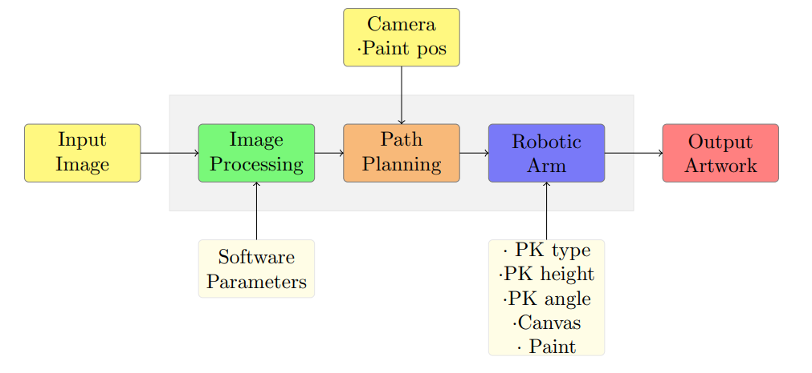
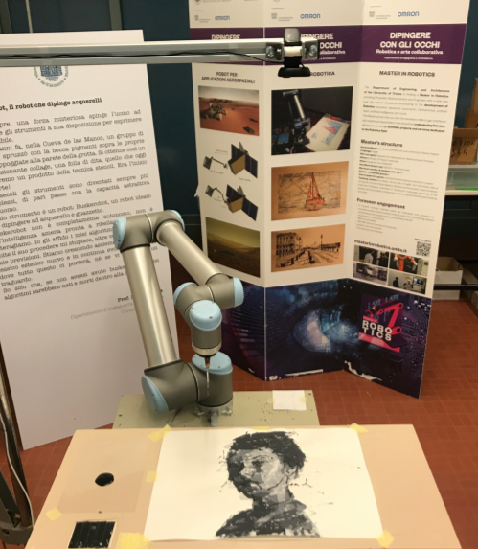
Figure 1. Example of a robotic painting system

This research study, to re-iterate, is to make multicolor paintings on upright easels with a robotic arm with a humanistic approach, which is an integration of ideas which have been thought of separately until now. One assumption was that the distance between the base of the robotic arm and the easel for this study was kept constant for the simulations and the same approach was to be followed for the physical tests with the hardware too. It is necessary to point out at this stage that the physical tests could not be completed due to restrictions in lab activities due to the onset of the COVID-19 situation. This research paper will first explain how a robotic arm would work in order to carry out the painting, including the theory for the processes that are undertaken.

2 painting robot mechanism and experimental results
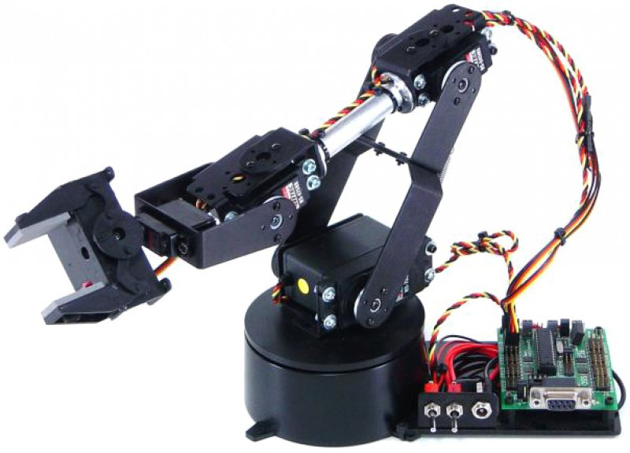
This segment gives an outline of the automated work of art framework, which comprises of direction arranging and picture handling calculations, and equipment parts: the LynxMotion AL5D mechanical arm, the easel, and paint.

Figure 2. LynxMotion AL5D robotic arm
The product for picture preparing and way arranging is executed in MATLAB, after an image is clicked by the webcam and the face or the element is recognized by OpenCV or PC vision. The framework gets a picture as information, which is then prepared by a calculation that worries the picture low frequencies and another that is utilized to underline the data on the high frequencies. The information extricated from the picture is changed over into ways that are trailed by the robot. The robot is controlled with the SSC-32U engine controller, whose movement can be mimicked utilizing the FlowArm PLTW condition and furthermore through code in MATLAB.
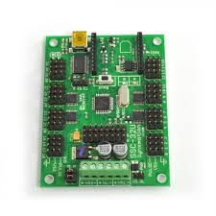
Figure 3. Flowchart to show software architecture
Figure 4. SSC-32U motor controller
Since the robot communicates with its condition, it has to know geometrical data (presents) about the working surface, the arm size, and the palette position.
2.1 tcp calibration
The device community point adjustment permits to distinguish the difference in organizes between the focal point of the robot end-effector and the device place point (TCP) utilizing interpretations and turns. The TCP alignment relies upon the end effector shape.
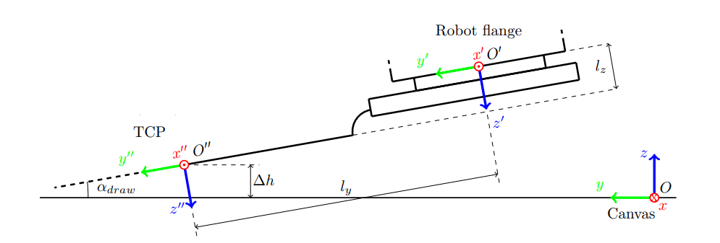
Figure 5. TCP calibration
The alignment accomplished for this examination study is a half and half framework between the human helped technique and the robotized one, on account of the webcam in a fixed situation on the head of the PC, plausible for a wide range of end effectors with various shapes and measurements.
2.2 PAINTING SURFACE CALIBRATION
The work of art surface adjustment permits to lessen mistakes due to the non parallelism of the easel with the robot arm base. Utilizing this strategy, the easel stature can be communicated as a technique for the end effector TCP position. In the alignment program the easel is utilized as the premise, the end-effector is then situated at each side of the easel and its position is spared. This procedure offers the situation of the easel corners and its estimations.
2.3 CAMERA TO ROBOT CALIBRATION
The webcam and the automated arm work with two distinctive reference outlines, which should be associated with each other through changes. For good accuracy, an earlier camera adjustment is required. At the point when the alignment programming is run, a live camera stream is appeared with four red specks overlaid on the picture. So as to decrease the parallax mistake during the procedure, the end effector must be practically contacting the easel.
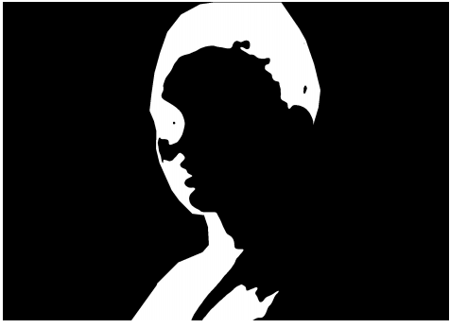
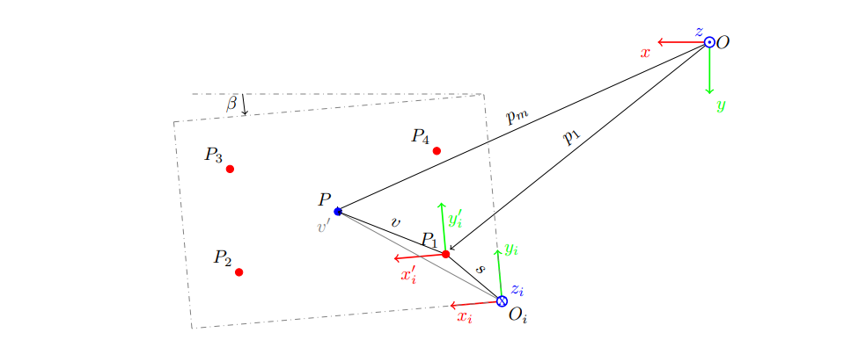
Figure 6. Camera to robot calibration
The square shape speaks to the vision field. The directions of the adjustment focuses as for the two casings are open gratitude to the performed alignment. The reason for the camera to robot alignment is to communicate focuses that we see on the screen because of the presentation of the webcam as for the robot reference outline.
2.4 IMAGE PROCESSING AND TRAJECTORY PLANNING ALGORITHM
In this fragment, the calculations created to process a picture and paint it on the easel are characterized. The calculations can be isolated into two sections: the main procedures the picture at low frequencies in this manner lower exactness, with the end goal of consistently filling huge territories, though the second is intended for the more precise handling with high frequencies
2.4.1 Low Frequencies Algorithm
In this investigation the procedure utilized is like bring forth, wherein a picture is partitioned into various layers, in light of dark scale edges. In this investigation, this calculation has been modified for a mechanical arm application, by remembering the position, yet additionally the direction that the arm needs to follow to paint a stroke along each line. The subject cover can be handily made sense of, since it includes a twofold picture containing the area of the considerable number of pixels of enthusiasm for the picture. The reference picture is changed in dark scale and afterward isolated into layers characterizing the parts where the picture has similar properties.
To top off the easel region with its connected paint tone, each layer is handled to get ways to be sent to the mechanical arm for the way arranging. The natural anomaly introduced by this strategy doesn't permit the watcher to watch the parallelism of the lines. The precise heading of the lines and their detachment separation ought to be chosen individually for each layer so the methodology appears to be increasingly masterful. This procedure is accomplished utilizing a double cover comprising of equal lines, whose direction and separation are inputted by the client. Each line compares to a way that the end effector needs to follow. In this way, it is helpful to search for the beginning and end focuses on each line, which can be comprehended by computing the extraordinary pixel places of each line. The accomplished focuses communicated in pixels in the picture reference outline, are changed as for the mechanical arm reference outline.
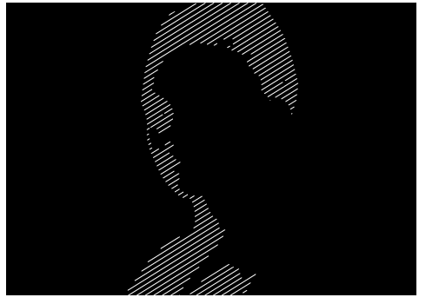 Figure 7. Low frequencies processing
All layer ways once determined are sent to the automated arm. Two techniques can be used to decide the request in which the ways are painted by the mechanical arm—the consecutive and the irregular strokes strategies. The successive technique mixes the request for the total directions, thus the automated arm completes the current chose way before moving onto the following way. In the irregular strokes technique every fragmented stroke are changed inconsistently and afterward sent to the automated arm. Whenever contrasted and the consecutive strategy, this method creates a resultant work of art involving less customary strokes, however the layer surface is typically secured sporadically because of the short paint drying time. The speed profile for the movement of the end effector is trapezoidal, comprising of increasing speed, consistent speed and deceleration.
2.4.1 High Frequencies Algorithm
This examination utilized the DOG channel to comprehend the picture subtleties. This channel is a gauge of the Laplacian of Gaussians channel [11], and is typically utilized for edge identification. The DOG can likewise be utilized with the standard convolution technique: right off the bat the channel portion must be determined characterizing the boundaries, at that point the channel is tangled with the picture. The got picture has numerous lines and branches. Prior to figuring the ways, it is important to isolate these branches in order to compute the courses in the most direct manner. In any case, a few highlights in the skeletonization are wiped out because of the manner in which the calculation is structured. This happens particularly for huge bits that can't be easily changed into lines and require a devoted layer to be drawn, for example, the eyes of the subject before the webcam.

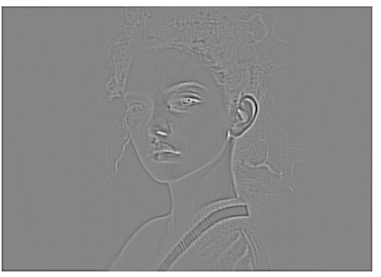
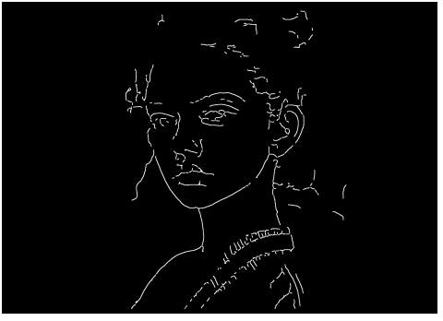
Figure 8. High frequency processing
The focuses from the skeleton picture are enunciated as for the webcam reference outline, in this way they must be changed over as for the automated arm reference outline. The transformation can be accomplished utilizing the achieved easel corner facilitates regarding the automated arm reference during the adjustment. To draw the highlights onto the easel the end effector must be lined up with the exact way. The most indispensable information in a rendered picture is ordinarily situated close to the picture place. Prior to transmitting the data or the boundaries to the robot, the product classes the directions: for the most part, the ways closer to the center of the picture have a propelled priority than the farther ones. Hence, the automated first paints the significant attributes that are essential to portray the artwork, which is the means by which a human would regularly paint and subsequently the humanistic methodology.
During this high recurrence calculation process, the automated arm moves directly with steady speed and round mixes. This permits to paint the points of interest all the more accurately and increasingly complex drawings can be painted. Critical wrist revolution can seizure the automated arm because of contamination of as far as possible. The execution of a mixing range assists with getting around this issue.
2.5 Programming architecture
Image processing is achieved in C++ using OpenCV computer vision functions. This code is then compiled into a .mex file that will be accessed from MATLAB. MATLAB uses the .mex functions created by a .cpp file to obtain path coordinates for planning the trajectory for the source image. This path planning algorithm is then used to generate drive commands for the LynxMotion AL5D arm, which will then execute the painting process for the source image.
From the MATLAB command line, the init function opens a serial connection to the robotic arm through the TCP/IP protocol as mentioned earlier. A function called drawPaths grabs a frame from the camera and tries to draw based on the commands received from the path planning algorithms.
This study has been verified using Visual Studio 2017 and MATLAB r2018b. Visual Studio will be used to open the OpenCV libraries and to build a project with a .mex target.

3 conclusion and future prospects
To conclude, this study is a testament to the fact that even though robotic painting has been around for a few decades, there are still many avenues to explore in this regard. This study was not completed as the physical testing procedures were not conducted, but this paper includes the calibration and simulation carried out to lead into the hardware testing. For future prospects, we can look into biomimicry to teach the robotic arm how to do brushstroke positioning and motion, and also looking into soft robotics applications to make a more realistic hand which can carry out more minute movements with the brush. Also, AI and supervised learning techniques can be incorporated to make the robotic arm smarter and more intelligent.

Acknowledgment
I would like to thank Assoc Prof Anupam Chattopadhyay for assigning me this project under the URECA program and supervising and guiding me throughout the research study with advise and valuable insight. I would like to acknowledge the funding support from Nanyang Technological University – URECA Undergraduate Research Programme for this research project. I would also like the writers of the paper “Artistic Robotic Painting Using the Palette Knife Technique”, as it served as the inspiration for my research study. I would also like to thank my parents and my friends for their constant support throughout this research study period.

References
- Beltramello, A., Scalera, L., Seriani, S., & Gallina, P. (2020). Artistic Robotic Painting Using the Palette Knife Technique. Robotics, 9(1),15.doi:10.3390/robotics 9010015 J. Clerk Maxwell, A Treatise on Electricity and Magnetism, 3rd ed., vol. 2. Oxford: Clarendon, 1892, pp.68-73.
- brewercg/DrawingRobot. (2020). Retrieved 27 June 2020, from https://github.com/brewercg/DrawingRobot K. Elissa, “DrawingRobot,” published on GitHub.
- Biography Jean Tinguely - Museum Tinguely. (2020). Retrieved 27 June 2020, from https://www.tinguely.ch/en/tinguely/tinguely-biographie.html
- Cohen, P. Harold Cohen and AARON. Ai Mag. 2016, 37, 63–66.
- Calinon, S.; Epiney, J.; Billard, A. A Humanoid Robot Drawing Human Portraits. In Proceedings of the 2005 5th IEEE-RAS International Conference on Humanoid Robots, Tsukuba, Japan, 5–7 December 2005; pp. 161–166.
- Aguilar, C.; Lipson, H. A robotic system for interpreting images into painted artwork. In Proceedings of the International Conference on Generative Art, Milan, Italy, 16–18 December 2008; p. 11.
- Lu, Y.; Lam, J.H.M.; Yam, Y. Preliminary study on vision-based pen-and-ink drawing by a robotic manipulator. In Proceedings of the 2009 IEEE/ASME International Conference on Advanced Intelligent Mechatronics, Singapore, 14–17 July 2009; pp. 578–583.
- Luo, R.C.; Hong, M.; Chung, P. Robot Artist for colorful picture painting with visual control system. In Proceedings of the 2016 IEEE/RSJ International Conference on Intelligent Robots and Systems (IROS), Daejeon, Korea, 9–14 October 2016; pp. 2998–3003.
- Luo, R.C.; Wang, H. Automated Tool Coordinate Calibration System of an Industrial Robot. In Proceedings of the 2018 IEEE/RSJ International Conference on Intelligent Robots and Systems (IROS), Madrid, Spain, 1–5 October 2018; pp. 5592–5597.
- Hallenberg, J. Robot Tool Center Point Calibration using Computer Vision. MSc. Thesis, Linkopings University, Linkoping, Sweden, 2007.
- Szeliski, R. Computer Vision: Algorithms and Applications. In Computer Vision: Algorithms and Applications, Texts in Computer Science; Springer: London, UK, 2011; pp. 238–242. ISBN 978-1-84882-934-3.

